2019 season
Technical facts and figures about Rulantica

In addition to 25 water attractions (including 17 water slides), the water adventure park is maintained by an innovative system of technology and machines behind the scenes.

Building management 4 systems to manage the heat, ventilation,
systems: cooling, pool technology visualisation, monitoring of all showers and light management/media technology visualisation

Water systems: 10 loops
4,386m³ of moving pool water

Pool water technology: The heart and soul of Rulantica
11 loops, 10 of which feature pressureless filters and 1 with a pressurised sand filter
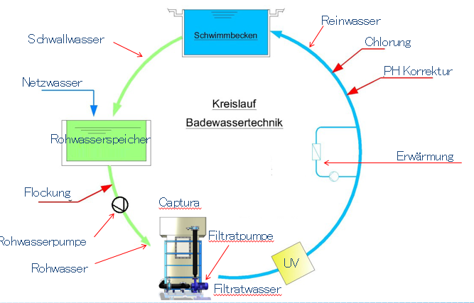

Ventilation systems: a total of 29, 19 of which are large (5,000 – 65,000 m³/h)
6 ventilation devices for air supply and exhaust of 65,000 m³/h each
Target indoor temperature: 32 – 34 degrees Celsius

Energy supply: 2 peak load boilers
producing 1.95 megawatts each
Supply for Rulantica and Hotel Krønasår

Cogeneration 2 at Rulantica (4 in total)
power stations: 15.5 million kilowatt hours per year
corresponds to the annual demand of 4,200 – 5,600 households

Rulantica opens on 28.11.2019. It is open daily from 10am until 10pm (9am for Europa-Park hotel guests). Limited capacity. Visitors must generally purchase a ticket online in advance for admission to the water world. Information hotline: +49 07822 77 66 55. Current information and ticket prices can be found at rulantica.com.

