Press release
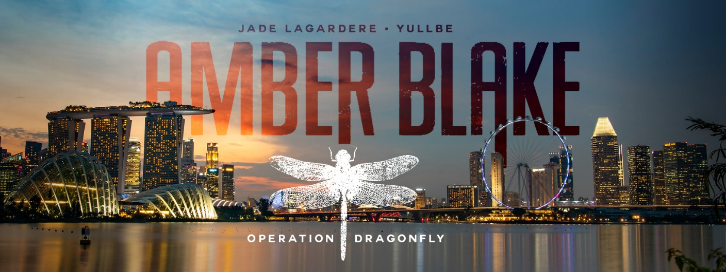
- approved for immediate release -

Hardcore Immersive Adventure for VR Agents in ‘Amber Blake: Operation Dragonfly’

VR experience from summer 2022 in the Europa-Park Resort
Rust, 17th March 2022 - The brand new experience ‘Amber Blake: Operation Dragonfly’ starts this summer at the standalone VR attraction YULLBE at the Europa-Park Resort. The immersive 3D thriller is based on the comic series 'Amber Blake' by Belgian supermodel Jade Lagardère and takes visitors into a 30-minute, interactive action film with a hardcore agent, a mysterious villain and a thrilling finale set against the stunning Singapore skyline. The 'full body tracking free roaming VR experience' is available to visitors from the age of 16.
Amber Blake is a highly intelligent fighter who became a victim of organised crime and now uses her skills to fight evil and make the world a better place. In the YULLBE PRO Experience 'Amber Blake: Operation Dragonfly', visitors find themselves in an undercover mission for the private agency Argon. In the dazzling metropolis of Singapore, they join Amber Blake on the hunt for one of the most dangerous criminals in the world, a key figure in organised crime. Whether its arms, drugs or human trafficking, the mysterious 'Blue Dragon' seems to have their hand in everything. However, to this day, his true identity has remained a mystery, one that even Interpol failed to solve. Now it's up to the players to unmask the 'Blue Dragon' together with Amber Blake.

During a game session, two teams each consisting of three people move independently through the specially prepared rooms at YULLBE, which also contain haptic elements. As one group infiltrates a masked ball, the second team tries to decode clues in a hotel room. The mission can only be successfully completed if both of them fulfil their respective tasks. But evil never sleeps, and so the mission quickly develops into a nerve-wracking thriller with a breathtaking showdown. In addition to the multiple different gameplay scenarios of the two team missions, different story sequences will be triggered depending on the decisions of the players, affecting the further course of the mission.

Michael Mack, Managing Partner of the Europa-Park Resort and founder of MackNeXT, discovered Jade Lagardère's comics during a stay in France, among other things in his function as French Honorary Consul. With offerings such as the new Amber Blake VR adventure, Mack also aims for a more targeted and strategic focus on the French and international media market. The technical equipment for YULLBE PRO has been adapted and expanded in order to implement the immersive secret agent thriller 'Amber Blake: Operation Dragonfly'. In addition to a revised version of the special YULLBE VR glasses, the secret agents that embark on 'Amber Blake: Operation Dragonfly' also receive a vest that transmits feedback to the players via vibrations in the event of being hit in a hail of bullets. The hand and foot trackers keep track of the exact location of each respective person in the room at all times, and this information is then transferred to the VR experience. Several subsidiaries from the Mack Group are working together on the realisation of the new experience. In addition to the MackNeXT innovation department, Mack Rides, Mack Animation and VR Coaster are also involved. With the opening of YULLBE in 2020, Michael Mack and his team have achieved a milestone in the digital entertainment industry.

Key Features:
- Unique multiplayer VR experience: Up to six players at the same time
- Two teams with different missions and dynamic twists
- Immersive 30-minute 'Full Body Tracking Free Roaming VR Experience'
- Special high-tech VR equipment consisting of VR glasses, vibration vest, hand and foot trackers
- 2D comic series transformed into an immersive 3D spy thriller

At the start of the season, in the Austria themed area, visitors to Europa-Park can find out whether they are suitable to go on a mission as a hardcore VR agent alongside Amber Blake. During a daring chase on the 'Alpenexpress Coastiality’, passengers can get a taste of what awaits them at the YULLBE PRO Experience 'Amber Blake: Operation Dragonfly'. Pparticipants ride jet skis in this virtual rollercoaster experience and glide over the waves of Marina Bay as Singapore's impressive skyline rises in the background, experiencing sharp turn after sharp turn in order to avoid obstacles and danger. The Mack Animation team have worked in great detail to ensure the digital jet ski adventure is perfectly coordinated with the rails of the 'Alpenexpress Enzian’, turning the 100-second ride into a rapid action film. One thing is for certain: this mission is certainly not for the faint of heart.

+++
The teaser trailer 'Who is Amber Blake?' shows how the 2D comic has been transformed into the immersive 3D agent thriller 'Amber Blake: Operation Dragonfly': https://youtu.be/iaAniyfFjW8

All YULLBE experiences are available in German, English and French. A separate ticket is required to visit the 600-square-metre VR attraction at a price of €9.90 for YULLBE GO and €29 for YULLBE PRO. Tickets are available in the Europa-Park Ticket Shop .

More information about the VR experience online at yullbe.com und europapark.de

Pressekontakt
SWORDFISH PR
Freyja Melhorn / Christine Raufer
amberblake@swordfish-pr.de
T.: 0049 89 961 6084 10
www.swordfish-pr.de

Pressekontakt Europa-Park
Europa-Park GmbH & Co Mack KG
Juliana Bachert
presse@europapark.de
T.: 0049 7822 77 14170
www.europapark.de

